**EFFICIENT OPERATION MODE SELECTION FOR IOT**

**EDGE DEVICES**

Mr. Voodara Devendar R. Vamshi Goud

*Electronics and Communication Engineering Electronics and Communication Engineering*

*Institute of Aeronautical Engineering Institute of Aeronautical Engineering*

Hyderabad, India Hyderabad, India

Voodaradevender@iare.ac.in Vamshigoud7426@gmail.com

M.v. Harshavardhan K. Uday

*Electronics and Communication Engineering Electronics and Communication Engineering*

*Institute of Aeronautical Engineering Institute of Aeronautical Engineering*

Hyderabad, India Hyderabad, India

harshavardhan@gmail.com uday@gmail.com

***Abstract*— IOT edge devices are turning out to be all the more broadly utilized in various applications, like modern computerization and smart homes. Cultivating is done as it was done in the old days. Being an agrarian country, soil, wetness, and ecological hardships are the key factors that influence Indian cultivating. Our ranchers moved up to develop utilizing forefront, contemporary advancements. The Internet of Things (IOT) framework has been effectively applied all around the world and has added to a wide range of fields. To increment crop yields, Indian ranchers need to execute shrewd farming frameworks. farmers can screen their fields, thanks to the proficiency of information arrangement from sensors, actuators, and modern electronic gadgets. This increase the productivity where farming become efficient in cost and time, IOT system has contributed to its application in many fields and proven to be successful. With the guide of shrewd horticulture, weather, and temperature data display can be anticipated by turning on and estimating soil dampness content and consequently providing supplies to the field. smart agriculture system can be operated with the help of networking technology detecting the clamminess of soil as far as dampness levels with the assistance of sensors that communicated to the course of module Arduino-UNO, and keeping up with temperature by giving intensity through led Drove lights utilized fundamentally in agriculture.**

***Keywords*: *Efficiency, Mode operation, IOT (Internet of Things),***

***Edge device, Sensors, Moisture detector, Connectivity, network, Temperature, smart Agriculture, Data display.***

# 1. INTRODUCTION

Cash crops comprise the items which return essentially more advantage to the agriculturists than the regular gathers and requests also. Meanwhile, the development of such harvests isn't generally completed in that frame of the climatic obstructions of the nation or weather conditions and these yields need escalated care for creating the best yields that could be possible with modern technology that’s been us on farming.

underwater imagery often suffers from inherent deficiencies, including low contrast, indistinct edges, and colour distortion, posing challenges for extracting meaningful insights. While efforts to capture clearer underwater images have been made, they primarily fall into two categories: developing specialized underwater cameras and employing underwater image enhancement techniques. With automation, even a hard task can be made more straightforward to proceed as it diminishes human exertion, work and furthermore decreases time utilization to a serious degree. The internet of Things (IOT) is a progressive worldview that interfaces ordinary items to the web, empowering them to send and get information.

At its centre, an IOT framework includes shrewd gadgets outfitted with sensors and actuators, correspondence conventions, and a cloud-based foundation. This venture proposes a Shrewd Water system and plant supporting Framework utilizing IOT innovation, combined with an easy to use web application. The framework coordinates soil dampness sensors, daylight sensors for light changes in spite of non-appearance of daylight, giving light energy by blue drove lights which contain metal chloride union in it for plant development and data framed to adjust watering plans schedule. Through the web app, users can monitor irrigation remotely by setting mode controls for time commands, ensuring optimal water usage for plants. This smart solution promotes efficiency, conservation, and convenience in agricultural practices.

This interconnected organization of edge gadgets which means figuring or handling gadgets shapes a unique framework, changing the manner in which we connect with the actual world.

# 2. LITERATURE REVIEW

1. In the study examined by M.D. Shoaib the significant impact of IOT technologies on the agricultural sector and the potential benefits they offer for improving farming practices. Explore various applications of IOT in agriculture, including precision farming, livestock monitoring, irrigation management, crop health monitoring, and supply chain optimization.

1. In the paper presented by Vinayak N. Malavade analysed the importance of real-time data collection, monitoring, and analysis using IOT devices and sensors deployed in the agricultural ecosystem. It emphasizes the role of IOT in farming, enabling farmers to make data- driven decisions for crop management, irrigation, pest control, and overall resource optimization.

1. In the paper presented by Bong-Hyun Kim, the authors present the implementation of a smart agricultural water management system using I0T-based remote monitoring. They focus on addressing the challenges of water management in agriculture. They introduced the concept of a smart water management system that integrates I0T devices, such as sensors and actuators, to collect real-time data on soil moisture, weather conditions, and crop water requirements.
2. In the paper presented by Waleed Abdallah, That presents an IoT-based system designed specifically to meet the needs of Palestinian farmers in controlling greenhouse agriculture. The paper highlights the importance of greenhouse agriculture in Palestine and the significance of optimizing resource usage, such as water and energy, to ensure sustainable and profitable farming practices. The authors introduce the IOT system, which employs sensors, actuators, and a central control unit to monitor and regulate various parameters in the greenhouse environment.

1. Then paper presented by N Aggarwal, the authors explore the implications of combining (Internet of Things) IOT and Artificial Intelligence (Al) technologies in the context of farming. They discuss how the integration of IOT edge device and Al can revolutionize traditional farming practices and improve agricultural outcomes. The authors discuss how IOT devices, such as sensors, drones, and smart machinery, can collect and transmit real-time data on various agricultural parameters, including soil conditions, weather patterns, and crop health.
2. In the paper presented by Tharek Abdul Rahman, The authors discuss the potential benefits of IoT and data analytics in agriculture, including enhanced productivity, optimized resource utilization, improved crop quality, and reduced environmental impact. They also address the challenges and limitations of implementing these technologies, such as data security and privacy concerns, lack of standardized protocols, and the need for technical expertise among farmers.
3. by paper presented by Swaraj, highlighted the importance of monitoring and irrigation in agriculture and the need for efficient resource management. The authors introduce the IoT-based system, which incorporates sensors, actuators, and a central control unit to collect real- time data on various parameters such as soil moisture, temperature, and humidity. They focus on the development and implementation of a system that leverages IOT technologies to improve farming practices and optimize water usage.
4. In the paper presented by Xiaohui Wang, The research paper highlights the significance of supply chain management in the agriculture sector, specifically focusing on the procurement, storage, transportation, and distribution of agricultural means of production. The authors discuss the challenges faced by traditional supply chains and the potential for IOT to address these challenges, and the authors present various applications of IOT in agricultural supply chain management.

These papers provide various insights focused on enhancing IOT usage. Each paper proposes a novel method to address common challenges such as power efficiency, feasibility, ease access and limited resource effectiveness due to scene-specific variations.

# 3. PROPOSED SYSTEM

## 3.1 SYSTEM DESCRIPTION

Figure 3.1 illustrates the stages of methodology undergone in this study. There are sections: Sensors that connected to Arduino UNO, then data claim, processing for actions to take that turns on system like water pump motor and LED light, according to given stipulated commands. All these phases are explained in detail.

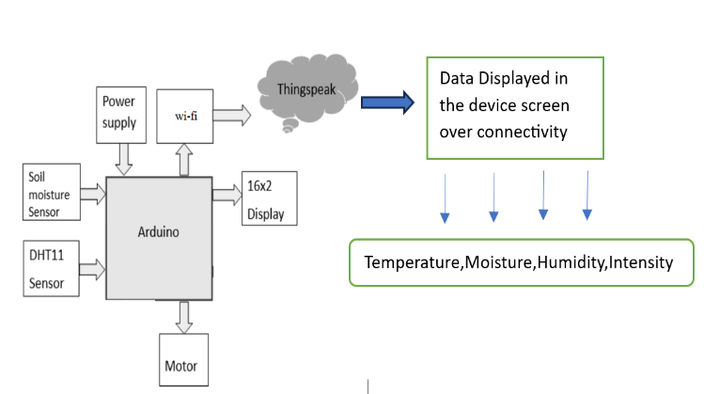

Fig 3.1.1 Basic Design of Architecture.

### 3.1.1 PROCESS FRAMING HARDWARE

At first the sensor like DHT 11, PIR sensor, Soil dampness sensor catch the information from the recorded and is passes to the microcontroller. Presently the microcontroller contrasts the got information and that of previous information and assuming the threshold point and the edge point the comparing gadgets goes to ON state. At first temperature inside the ranch is contrasted beyond and that of the pre-characterized esteem in the miniature regulator and in the event that it is past the edge point, the fan gets ON. Later soil dampness inside the ranch is contrasted and that of pre-defined esteem in the miniature regulator and on the off chance that it is past the edge point the alarm messages are send off to the ThingSpeak IOT application page through Wi-Fi module and is addressed in a graphical format. In the wake of reaching desired ideal level these gadgets consequently switches off.

Typically it requires 15 seconds to transfer information of every single sensor and this is a cyclic interaction. Where each update from field is ceaselessly passes the data or keeps the update.

**3.1.1** ARDUINO UNO

The most common version in Arduino is the Arduino Uno. This board is used by most people while talking about when they refers an Arduino. The UNO is one of the reputed boards in the Arduino family and a paramount choice for beginners. There are different revisions or versions of Arduino Uno, below mentioned detail is the most recent revision (Rev3 or R3). The Arduino Uno is a microcontroller board based on the ATmega328. It has 14 digital input/output pins (which 6 can be used as PWM outputs), 6 analog inputs, a 16 MHz ceramic resonator, a USB connection, an ICSP header, a power jack, and a reset button. It comprise everything needed.

Features: Microcontroller: ATmega328, Operating Voltage :5V, Input Voltage (recommended): 7-12V, Input Voltage (limits):6-20V*,* Digital I/O Pins: 4 (of which 6 provide PWM output)*,* Analog Input Pins : 6*,* DC Current per I/O Pin: 40 mA*,* DC Current for 3.3V Pin: 50 mA,

Flash Memory:32 KB (ATmega328) of which 0.5 KB used by bootloader,

SRAM:2 KB (ATmega328), EEPROM:KB (ATmega328), Clock Speed:16 MHz, Length :68.6 mm, Width:53.4 mm.

## 3.2 IMAGE OF ARDUINO UNO BOARD

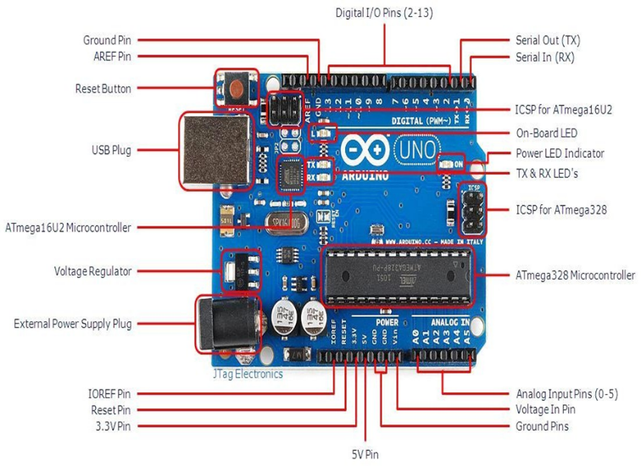

Fig 3.2.1 Arduino UNO

### 3.2.1 VOLTAGE REGULATOR

The voltage controller isn't really something you can (or ought to) interface with the Arduino. Whatever, its liable to help for realization that it is present what it's for. The voltage regulator does perfectly exact thing it utters - it control how much voltage that passed into the Arduino UNO board. Consider it a sort of guardian; it will dismiss an additional voltage that could harm the circuit. Of course, it has its cutoff points or limits, so don't attach your Arduino to anything more prominent than 20 volts.

**3.2.2 POWER PINS**

Voltage In Pin - The input voltage to the Arduino board while it's utilizing an outside power source (as went against to 5 volts from the USB connection or another directed power source). You can supply voltage through this pin, or on the other hand, if providing voltage by means of the power jack, access it through this pin. 5V Pin - This pin yields a controlled 5V from the controller on the board. The board can be comprised with power whether it be from the DC power jack (7 to 12V), the USB connector (5Volts), or the Vin pin of the board (7 to 12V). Providing voltage through the 5V or 3.3V pins sidesteps the controller, and can harm your board. It's not recommended.3.3V Pin - A 3.3volt supply generated by the on-board regulator or controller. More extreme current pulled is 50 mA.

**3.2.3 IOREF PIN**

This pin on the Arduino board gives the voltage reference with which the microcontroller works. An appropriately designed safeguard can peruse the IOREF pin voltage and select the suitable power source or enable voltage interpreters on the results for working with the 5V or 3.3V*.*

**3.2.4 INPUT AND OUTPUT PINS**

Every one of the 14 digital pins on the Uno can be utilized as an input or output. They work at 5 volts. These pins could be utilized for both computerized(digital) input (like telling event that a button got forced in or simply pushed) and computerized output (powering a LED). Each pin can give or get a limit of 40 mA and has an interior draw-up resistor (detached naturally) of 20-5k Ohms. Also, a few pins have capabilities or functions.

**3.2.5 SERIAL OUT (TX) AND SERIAL IN (RX)**

Used to get (RX) and communicate (TX) TTL sequential(serial) information. These pins are associated with the comparing pins of the ATmega8U2 USB-to-TTL Sequential chip.

**3.2.6 EXTERNAL INTERRUPTS**

Pins 2 and 3 can be designed to set off an interrupt on a low worth, a rising or falling edge, or an adjustment of significant worth. PWM - You might have witnessed the tilde (~) closed to a portion of the computerized digital pins (3, 5, 6, 9, 10, 11). These pins go about as expected computerized pins, yet can likewise be utilized for something many refer to as Heartbeat Width Regulation (PWM). Consider these pins having the option to mimic simple result (like blurring a Drove in and out). SPI - Pins 10 (SS),12 (MISO), 11 (MOSI),13 (SCK). SPI acronyms Sequential peripheral interface,

Fringe Connection point. These pins associates SPI correspondence making utilize of the SPI library. Simple Information Pins - Marked A0 through A5, every one of which give 10 bits of resolution (that is. 1024 distinct values). These pins can examine the sign from a basic sensor (like a temperature sensor) and convert it into a mechanized regard that we can scrutinize. As is normally done they measure from ground to 5 volts, but is it possible to change the upper completion of their compass using the AREF Pin (Addresses Basic Reference. Generally you can leave this pin alone). Besides, a couple of pins have explicit convenience: TWI - Pins A4 or SDA pin and A5 or SCL pin. Support TWI correspondence using the Wire library.

**3.2.7 LED INDICATORS**

Power Drove (LED) Pointer(indicator) - Just under and aside of "UNO" on your circuit board, there is somewhat Driven near the word 'ON'. This Drove (LED) should enlighten whenever you plug your Arduino into a power source. If this light doesn't turn on, there's a nice open door something is misguided. Time to re-really check your circuit out! Onboard Drove - There is an inbuilt Driven related with automated pin 13. Exactly when the pin is HIGH value(worth), the Drove is on, when the pin is LOW, it's off. This supportive to quickly check if the board has no issue as specific sheets has a pre-stacked direct gleaming Drove program in it. TX and RX LEDs - These LEDs will give us a couple of nice visual portrayals whenever our Arduino is getting or sending data (like while we're stacking one more program onto the board).

**3.2.8 RESET BUTTON**

Pressing the reset button make connection for time being to the reset pin to the ground and restarts any instructions of code that is dumped on the Arduino board. This could be much beneficial if your code don’t repeat or loops, but you need to test multiple times.

## 3.3 WI –FI MODULE (ESP8266)

The ESP8266 is a low-cost wi-fi chip with full TCP/IP stack and MCU (Microcontroller Unit) capability produced by Shanghai-based Chinese manufacturer. The chip first came to the attention of western makers in August 2014 with the ESP-01 module, made by a third-party manufacturer, AI-Thinker. This small module allows microcontrollers to connect to a Wi-Fi network and make simple TCP/IP connections using Hayes-style commands. However, at the time there was almost no English-language documentation on the chip and the commands it accepted. The very low price and the fact that there were very few external components on the module which suggested that it could eventually be very inexpensive in volume, attracted many hackers to explore the module, chip, and the software on it, as well as to translate the Chinese documentation.

Features include: ESP8285 is an ESP8266 with 1 MiB of built-in flash, passing make for one-chip devices capable of connecting to Wi-Fi32-bit RISC CPU: Tensilica Xtensa L106 working at 80 MHz* ,64 KiB of instruction RAM, 96 KiB of data RAM, External QSPI flash: 512 KiB to 4 MiB* (up to 16 MiB is handed/ supported),IEEE 802.11 b/g/n Wi-Fi ,WEP or WPA/WPA2 authentication, or open networks, 16 GPIO pins, 10-bit ADC.

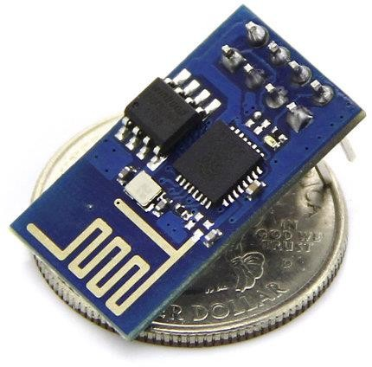

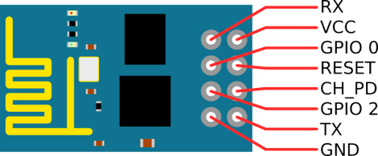

Fig 3.3.1 ESP8266WifiModule

**3.3.1 Temperature and humidity Sensor**

The temperature is drawn at a specific line and when it falls underneath the edge or threshold, the microcontroller conveys the message to the warmer to turn on and opens to standardize the temperature inside the nursery. On the off chance that the temperature climbs over the edge the microcontroller turns on the fans and shuts the vents to control the temperature inside the nursery. At the point when the humidity raises water drops begins shaping in the covering of the nursery so the microcontroller opens the vents and turns on the radiator to standardize the dampness(humidity) level inside the greenhouse. Here we have utilized temperature and humidity sensor module which detects the temperature and stickiness and conveys the message to the microcontroller

**3.3.2 Soil moisture sensor**

The sensor detects the moisture level of the soil and when it goes underneath the edge/threshold the microcontroller conveys the message to the motor siphon and water is trickled straightforwardly to the foundations of the plant through the drip water system framework and when required dampness came to, the engine siphon is turned off by the microcontroller consequently. The sensor utilized in our framework is the soil dampness sensor

**3.3.3 Light Sensor**

During evening/night time when the temperature decreases underneath the edge, the light sensor conveys the message to the microcontroller and the microcontroller in return, turns on the light, so well as the warming cushion to keep up with the temperature inside the nursery/greenhouse somewhat and subsequently the temperature can be kept up with. Here we have utilized INVNT_10Lm393 optical photosensitive LDR Light sensor module having DC 5V. This module is strong for on-board handling and storage capacity that permits it to be coordinated with the sensors and other application explicit gadgets through its GPIOs with minimized advancement front and centre and insignificant stacking (load) during runtime. It has serious level of on-chip combination that takes into account negligible outer hardware, including the front-end module, is intended to possess insignificant/minimal PCB region. The WIFI-module supports APSD for VoIP applications, Bluetooth concurrence interfaces, and it contains a self-aligned RF permitting it to work under every single working condition, and needs no outer RF parts.

**3.3.4 Power supply**

All computerized circuits require regulated power supply, to get a directed positive stockpile/supply from the provided mains supply.

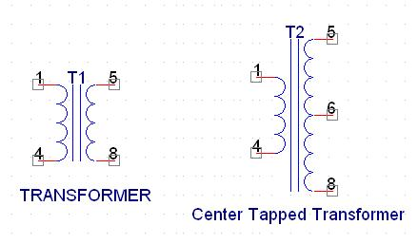**3.3.5 Transformers**

Fig 3.3.2 Transformers

A transformer comprises of two coils they are called as "WINDINGS" specifically Essential and Optional (primary and secondary). They are connected together through inductively coupled electrical conductors additionally called as Core. A changing current in the essential(primary) drivers an adjustment of the magnetic Field in the core and this thusly prompts an alternative voltage in the secondary loop. On the off chance that heap is applied to the optional(secondary), a rotating current will move through the heap. On the off chance that we consider an ideal condition, all the energy from the essential circuit will be moved to the secondary circuit through the attractive/magnetic field. secondary curl(coil) relies heavily on the number of turns the two sides that had.

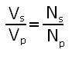Image

A rectifier is a gadget that changes AC signal into DC signal. For correction reason we utilize a diode for rectification, a diode is a gadget that permits current to pass just in one direction, for example at the point when the anode of the diode is positive as for the cathode additionally called as forward one-sided condition forward biased and blocks current in the turned around reverse sided condition.

**3.3.6 Bridge Rectifier**

As the name proposes it changes the full wave that is both the positive and the negative half cycle into DC hence it is significantly more proficient than Half Wave Rectifier and that too without utilizing a centre tapped transformer substantially more financially savvy than Full Wave Rectifier. Full bridge Wave Rectifier comprises of four diodes specifically D1, D2, D3 and D4. During the positive half cycle diodes D1 and D4 conducts while in the negative half cycle diodes D2 and D3 leads accordingly the diodes continue to switch the transformer associations (connections) so we get positive half cycles in the result.

In this event that we utilize a centre tapped transformer for an extension rectifier we can get both positive and negative half cycles which can in this manner be utilized for creating fixed positive and fixed negative voltages.

**3.3.7 Filter Capacitors**

Despite the fact that half wave and full wave rectifier give DC yield, not a solitary one of them gives a steady result voltage. We place the filter Capacitor at the result of the rectifier the capacitor will charge to the pinnacle voltage during every half cycle then, at that point, will release its put away energy gradually through the heap load while the corrected or rectified voltage drops to zero, subsequently attempting to keep the voltage as consistent as could be expected and smooth.

**3.3.8 Voltage Regulator**

A Voltage controller is a device that which converts differing input voltage into a steady managed yield voltage or constant regulated o/p voltage. switching controller manage the result voltage by turning the Current ON/OFF quickly. Since their result is either ON or OFF it disperses extremely low power in this manner accomplishing higher effectiveness when contrasted with direct voltage controllers. In any case, they are more perplexing and produce high commotion because of their exchanging activity. For low degree of result power exchanging controllers will generally be exorbitant however for higher result wattage they are a lot less expensive than straight controllers. Resistive Voltage regulator (linear voltage regulator) in light of the fact that they disperse the unnecessary voltage resistively as intensity or heat form

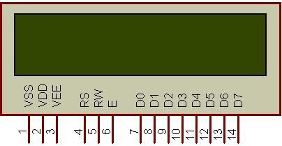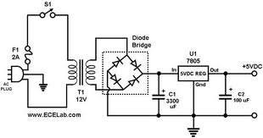

Fig 3.3.3 Circuit diagram of power supply

## 3.4 DISPLAY LCD

(Liquid Crystal Display Showcase) Displayed in fig.3.6 it is an electronic showcase module. A 16x2 LCD show is extremely essential module and is normally utilized in various kinds of gadgets and circuits. These modules are like north of seven fragment and other multi portion segments LEDs A 16x2 LCD implies it show 16 characters for every line and there are 2 lines. By this LCD each character is shown in 5x7 pixel framework matrix. This LCD contain two registers, that are command and Information (or) data. LCD show takes a period of 39-43µS to put a char or execute an order. Without that of clearing display and to look for cursor to home position which takes 1.53ms to 1.64ms. LCD show peruses information at the falling edge of the beat and executes it, same for the instance of transmission The data register stores the information to be displayed on the LCD. The information or data is the ASCII value of the character to be shown on the LCD.

## 

## 

Fig 3.4.1 LCD display 16x2

**3.4.1 Commands and Instruction set**

Just the guidance register (IR) and the information register (DR) of the LCD can be constrained by the MCU. Prior to beginning the interior activity of the LCD, control data is briefly put away into these registers to permit interacting with different MCUs, which work at various paces, or different fringe control gadgets. The interior activity of the not entirely settled by signals sent from the MCU. These signs indicate, which incorporates register signal (RS), read/compose signal (R/W), and the data or information transport from (DB0 to DB7), makes up the LCD directions. There are four classifications of directions that:

Assign LCD capabilities, for example, show design, information length, and so on. Set inside RAM addresses Perform information move with inside RAM. Carry out random roles or functions.

Fig 3.4.2 Liquid Crystal Displays Interfacing with Controller

The LCD standard requires 3 control lines and 8 I/O lines for the data bus system

# 4. REQUIREMENTS

## 4.1 Software description requirements

Software requirements pertain to specifying the necessary software resources and prerequisites that must be installed on a computer for a program to operate efficiently. Prior to Arduino IDE software. we can get various forms of Arduino IDE from the Download page on the Arduino Official site Sendoff Arduino IDE. After your Arduino IDE programming is downloaded, you want to unfasten the envelope. Inside the organizer, you can find the application symbol with an endlessness mark (application.exe).and ThingSpeak software to communicate between device over internet.

**4.2 Application procedure**

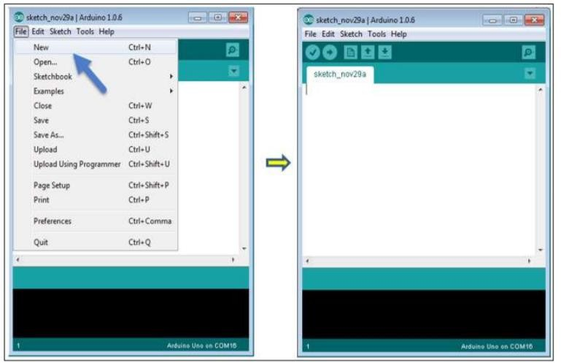Open your most memorable venture. When the product begins, you have two choices: click on create new project. Open a current venture/project model. To make another task, select 'File' and click 'new'.

Fig 4.2.1 Arduino Software application page

Here, we are choosing only one of the models with the name Flicker or blink. It turns the Drove on and off with some time delay

Sequential(serial) Port menu. This is probably going to be COM3 or higher (COM1 and COM2 are generally held for equipment sequential ports). To find out, you can detach your Arduino board and yet again open the menu, the passage that vanishes ought to be of the Arduino board. Reconnect the board and select that sequential port. just click the 'upload' button in the environment, stand by a couple of moments; you will see the RX and TX LEDs on the board, blazing. If the transfer is fruitful, the message "Done transferring" will show up in the status bar.

The source code for which the Java environment is provided under the GPL and the C/C++ microcontroller libraries are beneath the LGPL. Sketch: The primary phrasing is the Arduino program called "sketch". Structure Arduino projects can be distinguished in 3 fundamental parts: Design, Values (factors and constants), and Capabilities and functions used to code is: Arrangement () capability /setup () function, Circle() capability/loop() function in coding environment.

## 4.3 ThingSpeak Software Application

To associate an item to the IoT, a few things are required in the equipment hardware and programming software domain. Most importantly, on the off chance that one wishes to go past basically interfacing information from a PC, objects to assemble (sensors) or get (actuators) this case, the information should be transferred to an organization of associated servers which run applications. Such an organization is ordinarily alluded to as 'the cloud'. The cloud uses the course of representation, implying that few actual servers can be associated and utilized couple, yet appear to the client as one machine (regardless of that at the actual level, the machines capability autonomously). This technique for registering subsequently permits changes to be made to the 'virtual' server, (for example, programming updates or changes away space) a lot more straightforward than previously.

Actuators are something that you need to control. Things like indoor regulators, lights, siphons, and outlets. The IoT unites all that and permits us to communicate with our things and, much more strangely, permits things to connect with different things. To associate an item to the IoT, we centre around the ThingSpeak Programming interface The connection point gives straightforward correspondence capacities to objects inside the IoT climate, as well as fascinating extra applications, (for example, ThingTweet, which will be additionally examined in a later segment).

Additionally, ThingSpeak permits you to assemble applications around information gathered by sensors. All approaching information is time and date stepped and gets a successive ID. When a channel has been made, information can be distributed by getting to the ThingSpeak Programming interface with a 'compose key', a haphazardly made remarkable alphanumeric string utilized for validation.

Thus, a 'read key' is utilized to get to divert information on the off chance that it is set to keep its information hidden (the default setting) At the point when a gadget sends information through a HTTP demand (correspondence), it is handled by the IoT administration (for this situation ThingSpeak), which speaks with a virtual server. Both the server and the IoT administration discuss straightforwardly with the application.

At long last, at all degrees of correspondence from the gadget to the application there is the two necessities in regards to security and the board of the information move. Tragically, ThingSpeak doesn't record how the particular pieces of the outline are dealt with on a specialized level.

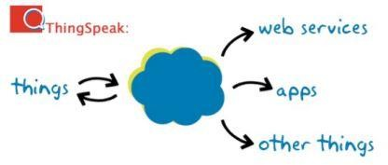Given sufficient opportunity and ability, it ought to anyway be feasible to respond to this by investigating the (open source) code base.

Fig 4.3.1 ThingSpeak applications

# 5. RESULTS AND DISCUSSION

As we have designed accordingly to our requirements which could be helpful in agriculture field and horticulture based beneficial by using IOT edge device and set a mode that operates itself. If temperature, humidity changes it shows in form of graph representation in ThingSpeak application that’s been installed in mobile phone or pc. Where drop of Moisture or light intensity leading to turn on LED light and Water pump successfully work.

## Image5.1 Interpretation and Graph

Fig 5.1.1 Continues out form voltage wave

We keep the Filter Capacitor at resultant of the rectifier, capacitor will charge to the high voltage during each half cycle, there after it would discharge its captivated energy steadily through the load, meanwhile the rectified voltage goes to null, so, hence hustling to maintain the voltage as constant as possible means

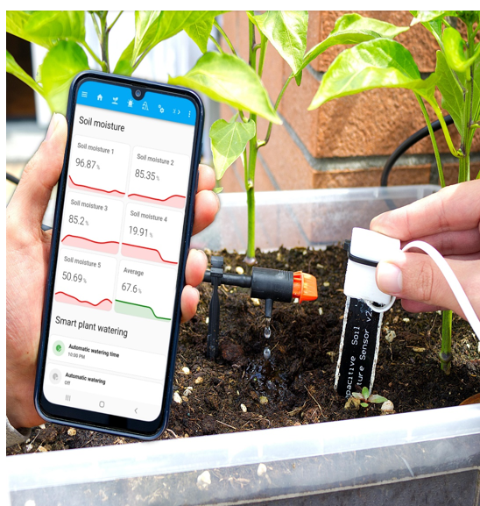

Fig 5.1.2 Graph representation on screen

Parameters such as Moisture, Humidity, Intensity, Temperature is shown on screen when connected to device over internet and keeps updating for every 30 seconds.

### 5.2 Working Model Board

### 

Fig 5.2.1 Working designed project model

Hence the model working is reliable and by connecting over network by smartphone to WIFI module of model designed we can read the values that prescribed on LCD on board and graphically in mobile.

The proposed plan is completely automated and everything is constrained by the microcontroller. It reduces the utilization of the work asset and just requirements legitimate management to ensure that everything is continuing without a hitch. As the govt of India is giving adequate credits to the improvement of ranchers and the country society through different plans so cash won't be a lot of obstruction in the development cycle of something similar. Likewise the benefit got will be considerably more than anticipated, so the ranchers can without much of a stretch reimburse the credits as soon as conceivable once after the yielding beginnings

# 6. CONCLUSION

In a developing nation like India, where upgrading is the primary wellspring of pay in by far most of the locale, people ought to realize about new advancements in this field with the objective that they can complete it in their developing sharpens and can be benefitted by a significant degree. Individuals truly need to get mindful of development of such money harvests and utilization of robotized plan and innovation and by executing it in their day to day routine can help them as well as the country to work on altogether both by socially, monetarily and monetarily.

As innovation keeps on propelling, the combination of man-made brainpower and AI calculations can be imagined to additional upgrade the framework's proficiency. Prescient investigation could be utilized to expect water system needs founded on authentic information, weather conditions estimate, and yield attributes, improving asset use significantly further. Moreover, the incorporation of remote detecting advances and robots might give ongoing visual bits of knowledge into crop wellbeing and development designs. Joint effort with shrewd cultivating drives and the consolidation of information from different

the incorporation of remote detecting advances and robots might give ongoing visual bits of knowledge into crop wellbeing and development designs. Joint effort with shrewd cultivating drives and the consolidation of information from different agrarian sources could prompt complete, information driven decision-production for ranchers. Moreover, the versatility of the framework could

be extended to cover bigger horticultural scenes, encouraging manageable practices on a more extensive scale.

# 7. FUTURE WORK

Joining of computer based intelligence and AI that which Integrating man-made reasoning (Artificial intelligence) and AI (ML) calculations or algorithms into IoT frameworks can empower prescient investigation for crop yield assessment, illness location, and vermin the board. Future exploration might investigate more complex artificial intelligence models prepared for huge scope rural information to further develop dynamic in cultivating rehearses.

Mechanical Cultivating and Automation through robotics, It is the reception of advanced mechanics and computerization in agribusiness is supposed to increment, driven by headways in IoT advancements. Future works might zero in on creating independent automated frameworks outfitted with IoT sensors for undertakings, for example, accuracy planting, reaping, and weed control, prompting expanded proficiency and efficiency on the homestead or productivity on farmland.

Edge Figuring Improvements or computing in edge technology advances will empower more proficient information handling and examination straightforwardly at the edge of the organization. Future works might zero in on creating lightweight calculations and upgraded structures for edge gadgets to deal with complex agrarian information continuously, along these lines diminishing idleness and further developing responsiveness.

## REFERENCES

[1] Ala Al-Fuqaha, Mohsen Guizani, Mehdi

Mohammadi "Internet of things: a review and

empowering innovations, conventions and

application", IEEE Correspondence Studies and

Instructional exercises, No. 4, 2015.

[2] Mohammad Abdur Razzaque, Marija Milojevic-jevric

Andrei Palade, and Siobhán Clarke, about

“Middleware for Web of things: a review", IEEE Web

Of Things Diary, Vol. 3, No. 1, February 2016.

[3] Hosenkhan, Reza, and Binod Kumar Pattanayak, "A

Got Correspondence Model for IoT", In Data

Frameworks Plan and Keen Applications, pp. 187-

193. Springer, Singapore, 2019.

1. Mayuri A. Bhabad and Sudhir T. Bagade, "Web of Things: Design, Security Issues and Counter measures" Worldwide Diary 2015.
2. Xue Yang, Zhihua Li, Zhenmin Geng and Haitao Zhang ,"Web of Things" Worldwide Studio on IOT, 2012, Changsha,2012
3. L. Atzori, A. Iera, and G. Morabito, "The Internet of Things: A review," PC Organizations, 15, pp. 2787-2805, Oct. 2010.
4. Potamitis, I., Eliopoulos, P. and Rigakis, I., “Automated remote insect surveillance at a global scale and the internet of things”, Robotics, 6(3), p.19, 2017.
5. D.O.Shirsath, Punam Kamble, Rohini Mane, Ashwini Kolap, R.S.More, “IOT Based smart Greenhouse Automation Using Arduino”, International Journal Of Innovative Research in Computer Science & Technology(IJIRCST), 2017.
6. Remya Koshy, M D Yaseen, Fayis K, Nisil Shaji,Harish N J,Ajay M, “Greenhouse Monitoring and Control Based On IOT using WSN”, ITSI Transaction On Electrical and Electronics Engineering(ITSI-TEEE),Vol4,Issue-3,2016.
7. C.R.Dongarsane, Patil Pranav Balasaheb, Patil Nilesh Rangrao , Patil Pranit Ramesh, “Greenhouse Automation using IoT”, International Research Journal Of Engineering and Technology(IRJET), e-ISSN:2395- 0056, 2017.
8. M. F. Siddiqui, A. Rehman Khan, N. Kanwal, H. Mehdi, A. Noor and M. A. Khan, “Automation and monitoring of greenhouse”, ICICT, Karachi, pp. 197-201, 2017.
9. S. Vaishali, S. Suraj, G. Vignesh, S. Dhivya and S. Udhayakumar, “Mobile integrated smart irrigation management and monitoring system using IOT”, ICCSP, Chennai, pp. 2164-2167, 2017.
10. Das, Rama Krushna, Manisha Panda, and Sweta Shree Dash, “Smart Agriculture System in India Using Internet of Things”, In Soft Computing in Data Analytics, pp. 247-255. Springer, Singapore, 2019.
11. W. Shi, J. Cao, Q. Zhang, Y. Li, and L. Xu, “Edge computing: Vision and challenges”, IEEE Internet of Things Journal, 2016.
12. F. Samie, V. Tsoutsouras, S. Xydis, L. Bauer, D. Soudris, and J. Henkel, “Computation Offloading and Resource Allocation for low-power IoT Edge Devices”, in WF-IoT, 2016.

**BIOGRAPHY**

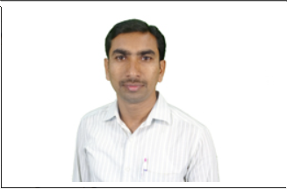

***Mr. D. Voodara devendar*** *currently working*

*as Assistant Professor at Institute of Aeronautical Engineering,*

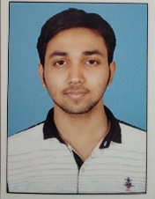

***R. Vamshi Goud*** *currently pursuing final year bachelor’s degree in Electronics and Communication*

*Engineering at Institute of Aeronautical engineering.*

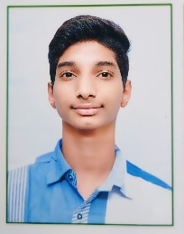

***M.V. Harshavardhan*** *currently pursuing final year*

*bachelor’s degree in Electronics and communication Engineering at Institute of Aeronautical engineering.*

 ***K. Uday*** *currently pursuing final year*

*bachelor’s degree in Electronics and communication Engineering at Institute of Aeronautical engineering.*